Policy & Procedure | Fee Waiver Policy 2022-23
Policy Area | Finance
Version Number | 02
Approving Committee | SMT
Date of Approval | July 2022
Date of Equality Impact Assessment | July 2020
Date of Next Review | July 2023
Responsible Senior Manager | Director of Finance

History of Amendments

Date | Version/Pages/Sections Affected | Summary of changes
9 August 2021  16 June 22 | 1. Eligible Status  4. Responsibilities  - Eligible Students | Include reference to Student Information Scotland (SIS) portal.  Amend reference to Fee Policy and removal of option to pay at campus  Flexibility on Credit guidance for short re-skilling & upskilling programmes

Policy Statement
West College Scotland supports the principle of Lifelong Learning. To assist students who may be financially disadvantaged, the College operates a Fee Waiver Policy in line with the Scottish Funding Council current fee waiver policy guidance (SFC/GD/12/2022) which allows certain categories of student to have their fees waived. Each course of study must be fundable and attract credits.

Equality Statement
The College is committed to providing equal opportunities to ensure its students, staff, customers and visitors are treated equally regardless of gender reassignment, race, religion or belief; disability; age; marriage and civil partnerships; pregnancy and maternity; sexual orientation; sex.

Please note this document is available in other formats, to request another format please email info@wcs.ac.uk

Contents

1. Eligible Students 5
2. Residency 7
3. Other Conditions 8
4. Responsibilities and Assessment 9
APPENDIX A – Eligibility for fee waiver 10

1. Eligible Students
  - The College may apply a fee waiver in respect of activity for any of the following types of students:

- Further Education (FE) students following a full time non-advanced programme for whom SFC credits can be claimed.

- Students on courses which do not meet the current definition of full-time but would have been classified as full-time under the previous definition are eligible for a non-means-tested part-time fee waiver based on the credits for the course.

- Students on short-full time courses maybe allocated a fee waiver if the student is assessed as eligible for bursary student support.

- Flexibilities have been introduced to the Credit guidance on claiming credits for short re-skilling and upskilling programmes. Students on short-full time courses may be allocated a fee waiver.

- FE Students for whom SFC credits can be claimed with learning difficulties or disabilities on courses classified in price group 5.

- Students for whom SFC credits can be claimed and who are studying either:
  - a part-time FE programme; or
  - a part-time HE programme equivalent to at least SCQF level 7.

- School pupils undertaking College activity that form part of their school-based curriculum.

- Privately or home educated school pupils subject to means testing.

- Other students under the age of 16 completing any above activity out-with their school-based curriculum on a means tested basis.

1.2 Fees for full-time advanced courses are assessed and paid, if eligible, by SAAS. Fees for these courses are therefore not subject to the College Fee Waiver Policy.

Part-Time Students
1.3 Part-time students (referred to in paragraph 1.1(e) above) should satisfy the
criteria below. The benefits and tax credits referred to relate to the UK benefit
and tax credit system only:

a) The student or student’s family are in receipt of either:
- Income Support
- Working Tax Credit
- Pensions Credit
- Income based Job Seekers Allowance
- Income Related Employment & Support Allowance (ESA)
- Housing Benefit
- Universal Credit

b) Or the student is in receipt of:
- Carer’s Allowance (or carers who have an ‘underlying entitlement’ to Carer’s Allowance but gave up the allowance to e.g., claim their pension), Carer’s Allowance Supplement or the Young Carer’s Grant
- Disability Living Allowance
- Attendance Allowance
- Incapacity Benefit
- Contributory Employment & Support Allowance (ESA)
- Personal Independence payment

c) Or the taxable income of the student’s family in the previous financial tax year (2021-22) is equivalent to or lower than the threshold below:

Households with only one person £ 8,282
Households of a couple no children £12,395
Households with dependent Children £18,977

If there has been a material reduction in income from the previous financial tax year the taxable income of the student’s family in the current financial tax year can be assessed

d) Or the student is a person, or the spouse or child of a person who is an asylum seeker living in Scotland (defined in section 18 of the Nationality, Immigration & Asylum Act 2002).

e) Or the student is under 26 and care experienced. This is defined as looked after and in the care of a local authority and can include situations where the student is living in a foster home, children’s home, residential home, in kinship care or in the care of the local authority in their own home.

1.4 With reference to 1.3(d) above, the further criteria to meet eligibility are that:
- the student’s asylum application (their own or their family application) must have been made prior to the end of 2006; and
- was under 18 years old on the date when the asylum application was made; and
- has been resident in Scotland for a minimum period of 3 years; and
- is under 25 years old on 1 August, 1 January, 1 April, or 1 July closest to the beginning of the first term of the course; and
- is resident in Scotland on 1 August, 1 January, 1 April, or 1 July closest to the beginning of the first term of the course.

Students on short full-time courses
  - Colleges can allocate a fee waiver and other student support to students on short full-time courses where the student has been assessed as eligible for bursary support. However, this will not apply to ‘closed’ courses or those being privately funded by employers.

Additional flexibilities have also been introduced to SFC’s Credit Guidance on claiming credits for short re-skilling and upskilling programmes.

Residency
  - The College will be able to apply a fee waiver in respect of the activity of a student, only if they meet the criteria set out in this document and they are eligible for support based on residence:

- That person falls with the definition of eligibility in Schedule 1 of The Education (Access Funds) (Scotland) Determination 2022. The current residency regulations are on the SFC website. OR

- The student is ordinarily resident in Orkney or Shetland on the date of commencement of the course of study and has been ordinarily resident in the British Islands throughout the previous three years and is settled in the UK within the meaning of the Immigration Act 1971 on the relevant date. OR

- The student is a person (or the spouse or child of a person) who is an asylum seeker living in Scotland on either a full-time English for Speakers of Other Languages (ESOL) course or a part-time non-advanced or advanced course. OR
- The student is a child of an asylum seeker or a young asylum seeking person on a full-time non-advanced course (excludes ESOL) and meets the criteria outlined in paragraph 2.2 OR

- The student is a non-asylum seeker living in Scotland on a part-time ESOL course and the student’s main purposes for being in the European Union (EU) is not to receive education (note that these students are still subject to the requirements as stated in paragraph 2.2).

  - If the student does not meet the ‘Long Residence’ requirement, the criteria
referred to in paragraph 2.1 (d) are that the student’s asylum application (their own or their family’s application) must have been made prior to the end of 2006, and the student:

- Is resident on 1 August, 1 January, 1 April, or 1 July closest to the beginning of the first term of the course.
- Has been resident in Scotland for a minimum period of three years.
- Was under 18 years old on the date when the application for asylum was made (the application must have been made prior to 1 December 2006).
- Is under 25 years old on 1 August, 1 January, 1 April or 1 July closest to the beginning of the first term of the course.

2.3 Further guidance on the impacts of Brexit, the Ukrainian conflict and changes to FE residency are expected to be made. A revised Policy will be issued if required.

3. Other Conditions
3.1 Determination of status is complex, but students can check this be accessing the Scottish Government, Student Information Scotland (SIS) Portal at https://www.studentinformation.gov.scot The portal also contains information for students on funding and finance.

3.2 The student must, where necessary, provide the College with evidence of their eligibility status.

3.3 If a student’s circumstances change during their course so that they become eligible when they were not previously, the student must notify the College before the ‘required date’ which is set as either:
- 1 November for full-time courses starting in the summer session; or
- The date on which 25% of the course duration in days has elapsed for other FT and PT courses.

3.4 There is no upper or lower age limit on student’s eligibility for fee waiver grant.

4. Responsibilities and Assessment
4.1 Where a student has chosen the Fee Waiver option on their course Enrolment Form, they must then complete a Fee Waiver Form and provide evidence of the benefits they are in receipt of for each course of study.

4.2 Each application will be assessed to ensure the criteria set out in the SFC Fee Waiver Policy, adopted by the College in this document, meets the necessary criteria. Students whose applications are successful will not need to fund their course fee.

4.3 Where an application is unsuccessful, the student will be advised that they need to pay their own tuition fees. Students should refer to the College Fee Policy for the options available for payment of course fees.

5. Review

5.1 This Policy will be reviewed annually in advance of the start of each academic session.

APPENDIX A – Eligibility for fee waiver
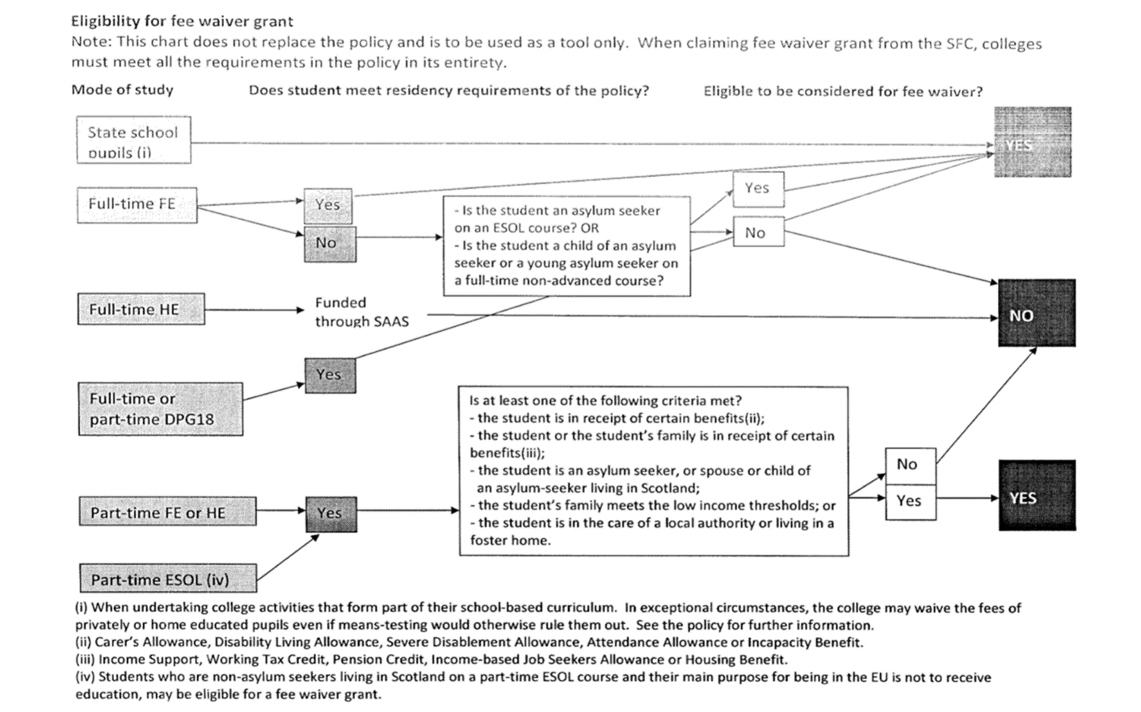

Equality Impact Assessment

Name of policy/procedure/decision: Fee Waiver

Provide a brief summary of the aims of the policy/procedure/decision and main activities:
This Policy allows certain categories of students who may be financially disadvantaged to have their fees waived in line with the Scottish Funding Council current policy guidance.

Assessed By: Clare Fraser Date: 20 July 2020

This stage establishes whether a policy, procedure or decision will have a differential impact from an equality perspective on people who share protected characteristics or whether it is “equality neutral” (i.e. have no effect either positive or negative).

The protected characteristics are: age, disability, gender reassignment, pregnancy or maternity, race, religion or belief, sex and sexual orientation.

1. Who will benefit from this (students/staff/stakeholders)? Is there likely to be a positive impact on people who share protected characteristics, and if so, how? Or is it clear at this stage that it will be equality “neutral”? i.e. will not have a differential impact on any equality group/s?

Protected groups are more likely to suffer financial advantage. For example, people with a disability face economic barriers, and asylum seekers have comparatively limited options in terms of seeking work. This Policy should therefore assist financially disadvantaged groups who may not otherwise have been able to enrol on a course in further education. Attainment could also assist them in gaining employment or in gaining citizenship skills which should also have a positive impact.

2. Is there likely to be an adverse impact on people who share protected characteristics? If so, who may be affected and why? Or is it clear at this stage that it will be equality “neutral”?

It is not anticipated that an adverse impact will occur. The College will provide support for those who require it in the implementation of this Policy and in the application and enrolment process.

3. What action will you take to ensure that you are monitoring the impact of this Policy?

Student equality data regarding applications, attainment and retention is collected and analysed, and used to inform action planning.

