Equality Outcomes
2021-2023

Overview
Timeframe
The Specific Equality Duties (Scotland) Regulations state that listed authorities must use equality evidence to develop Equality Outcomes which will enhance how the authority can pay due regard to the General Equality Duty, namely the duty to advance equality, eliminate discrimination and promote good relations.
The Regulations state that Equality Outcomes should be developed at least every four years. These Outcomes set out what we want to achieve in a two year period as opposed to four. The reason for this shorter timeframe is because of the extraordinary circumstances – we want to be as responsive as we can as soon as we can.
We anticipate that our Equality Outcomes will be iterative, and emerging data will drive how we proceed.
Equality Evidence
A comprehensive portfolio of evidence which we used to develop these Outcomes is published in our EDI Report 2021.
This document sets out the main rationale for our Equality Outcomes and key methods to achieve these. It is accompanied by an Action Plan which sets out the timeline, responsibilities and indicators of success.
Equality Outcomes 2021-2023
- During and post pandemic, staff and students from protected groups are supported and engaged in the recovery process
- We stand up to racism and progress race equality
- We enhance the wellbeing of all our staff and students
- We are digitally inclusive

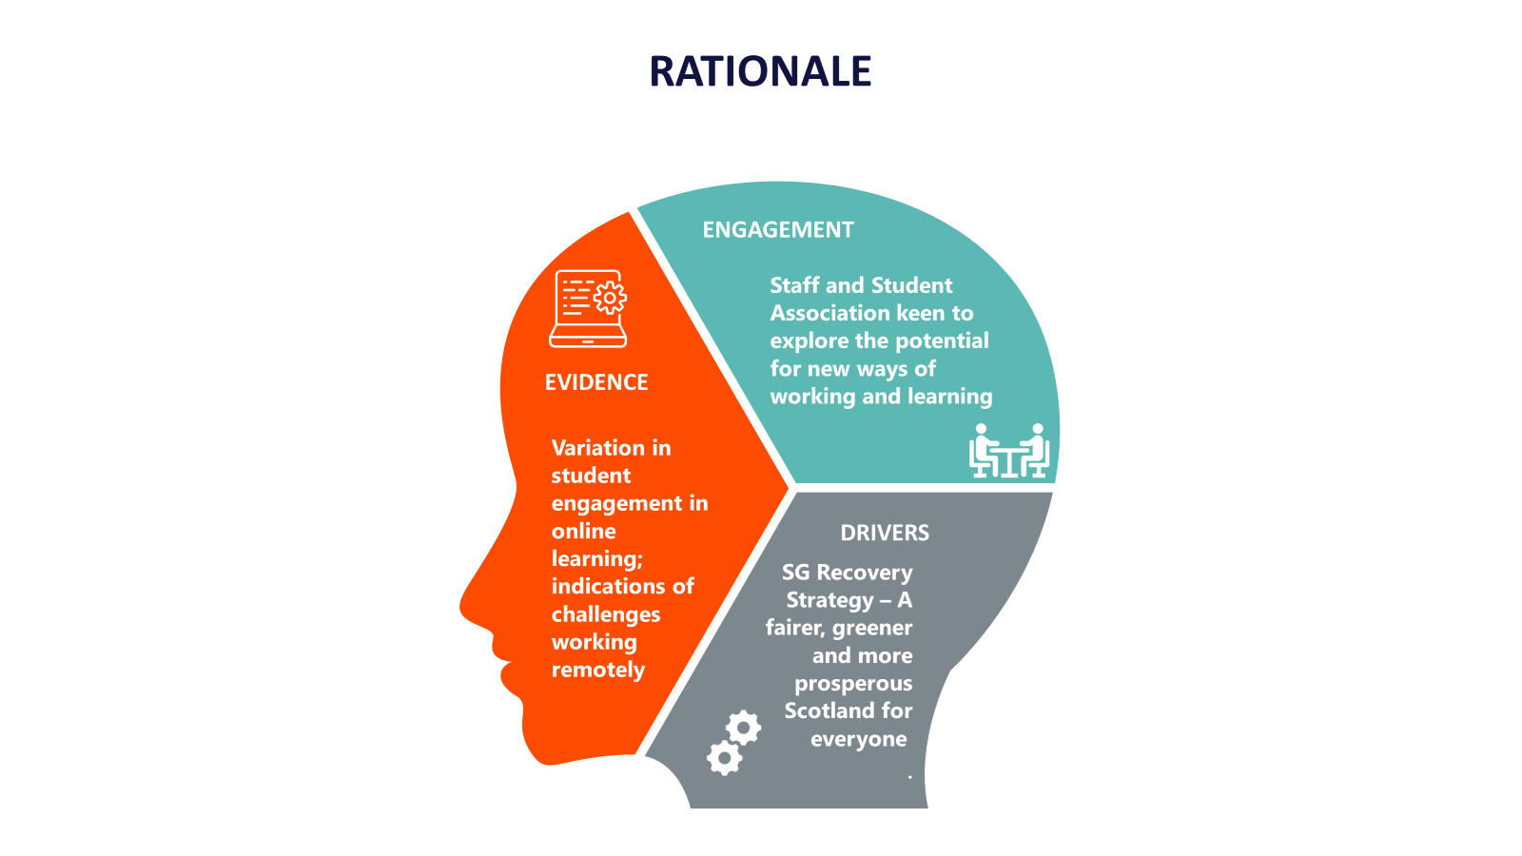
Outcome 1: During and post pandemic, staff and students from protected groups are supported and engaged in the recovery process.

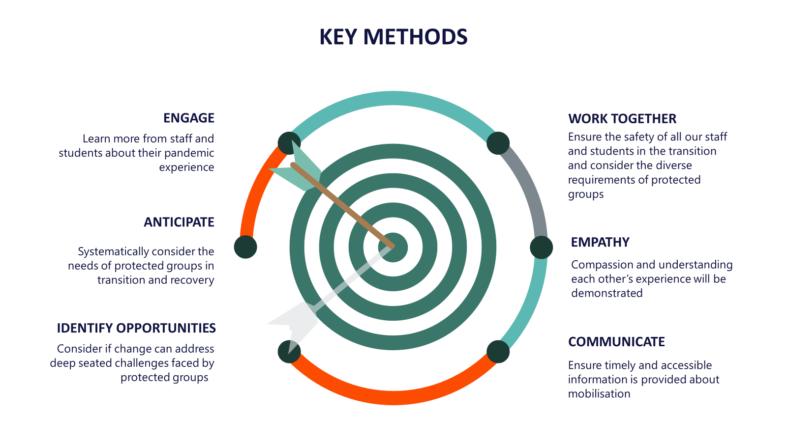

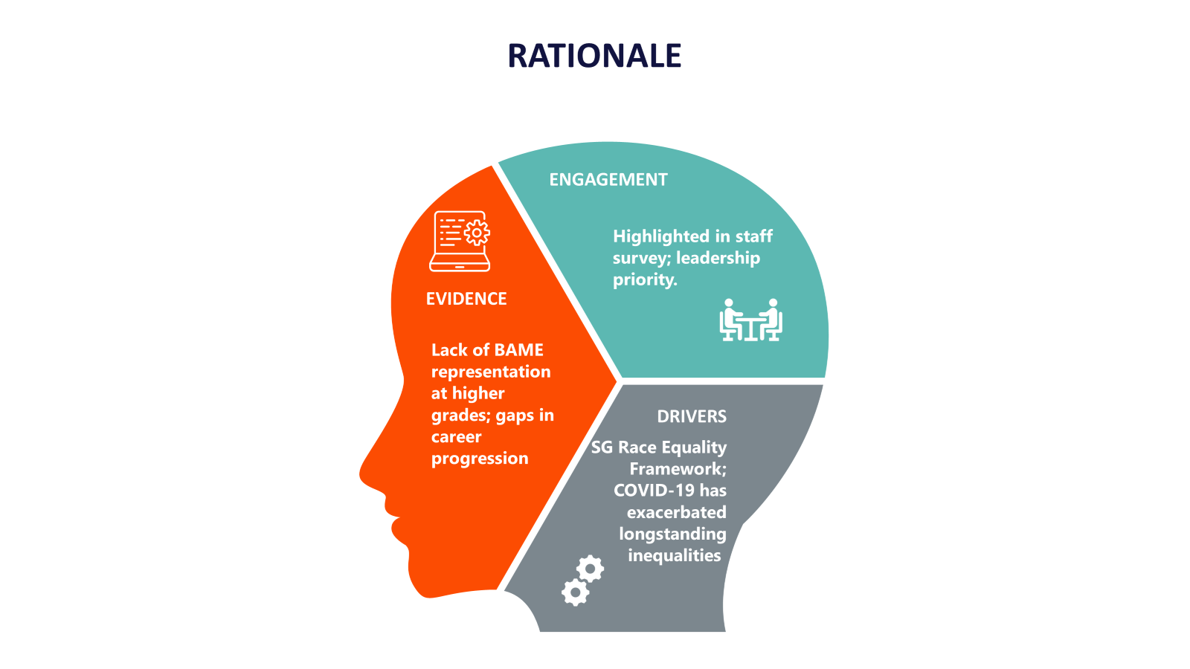
Outcome 2: We stand up to racism and progress race equality.
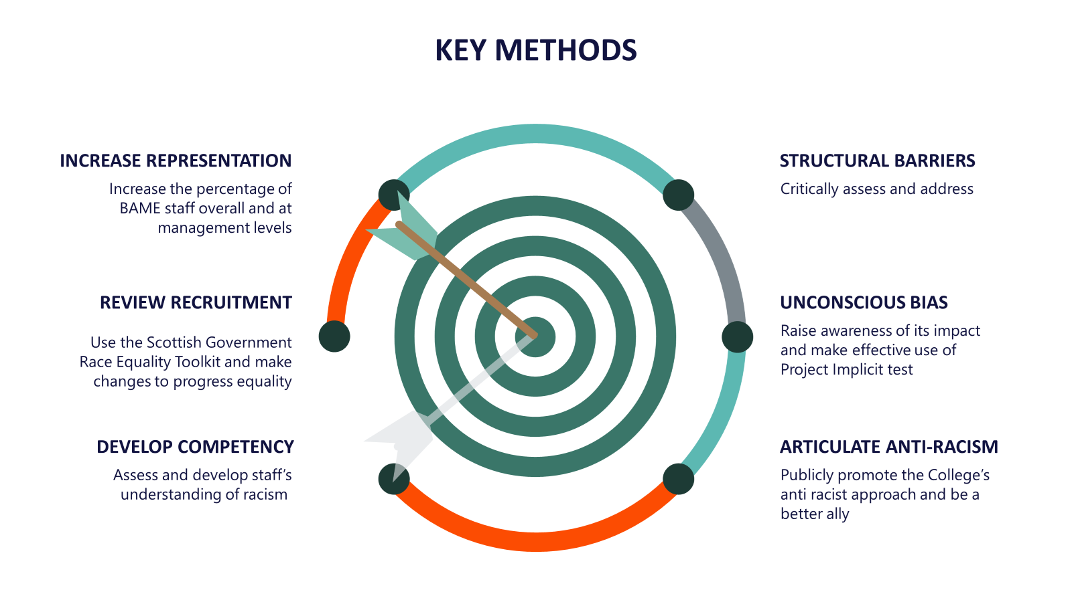

Outcome 3: We enhance the wellbeing of our staff and students
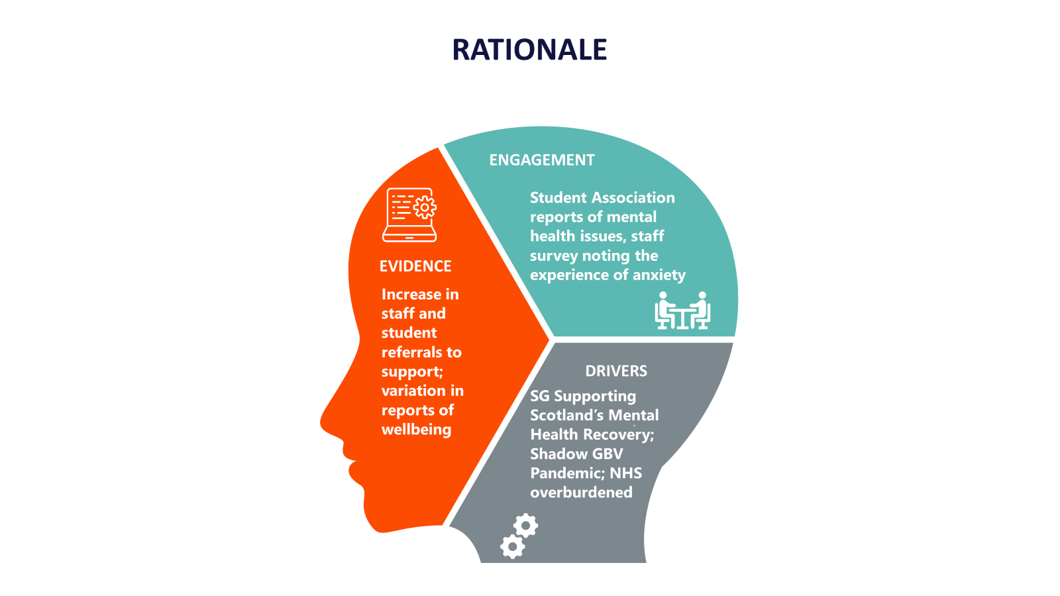
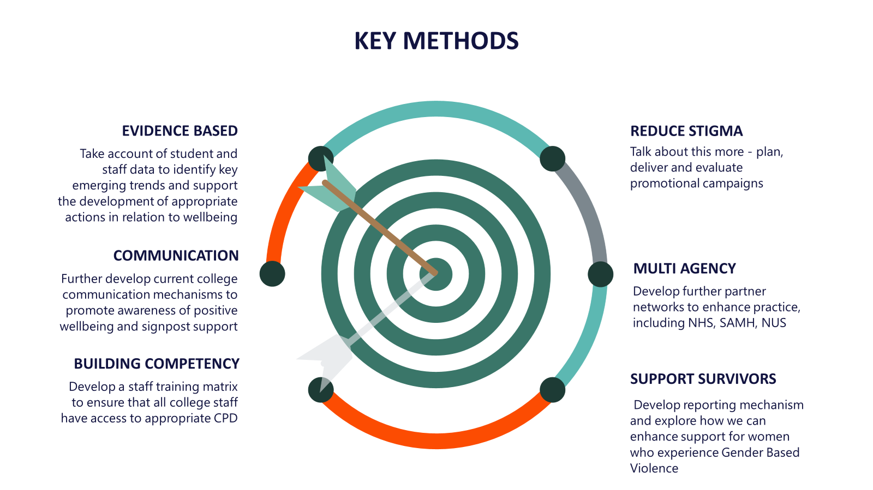

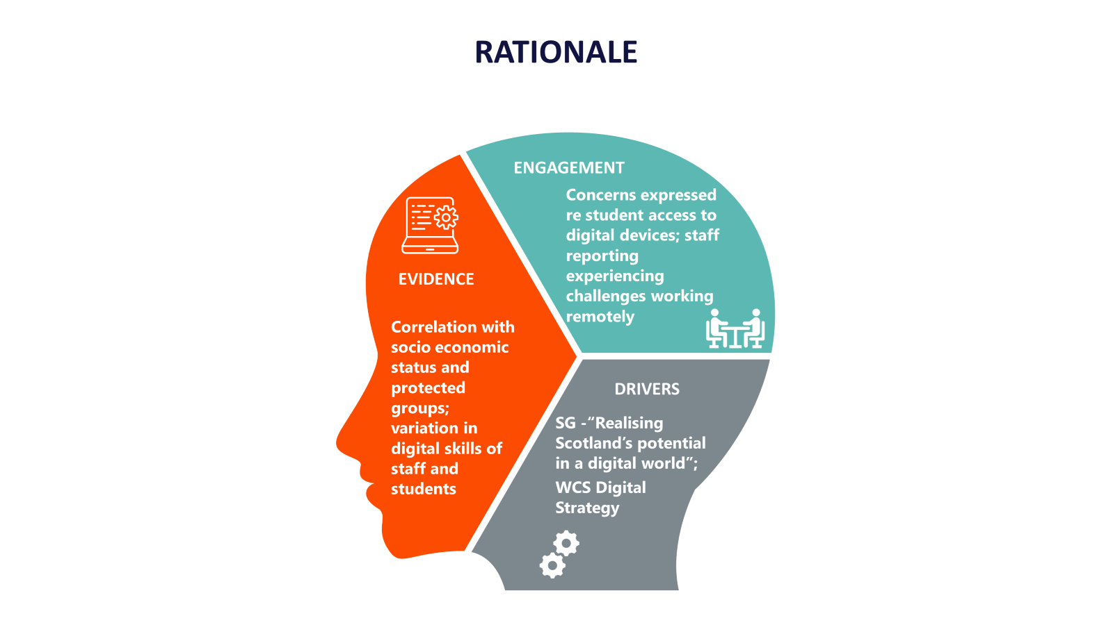
Outcome 4: We are digitally inclusive

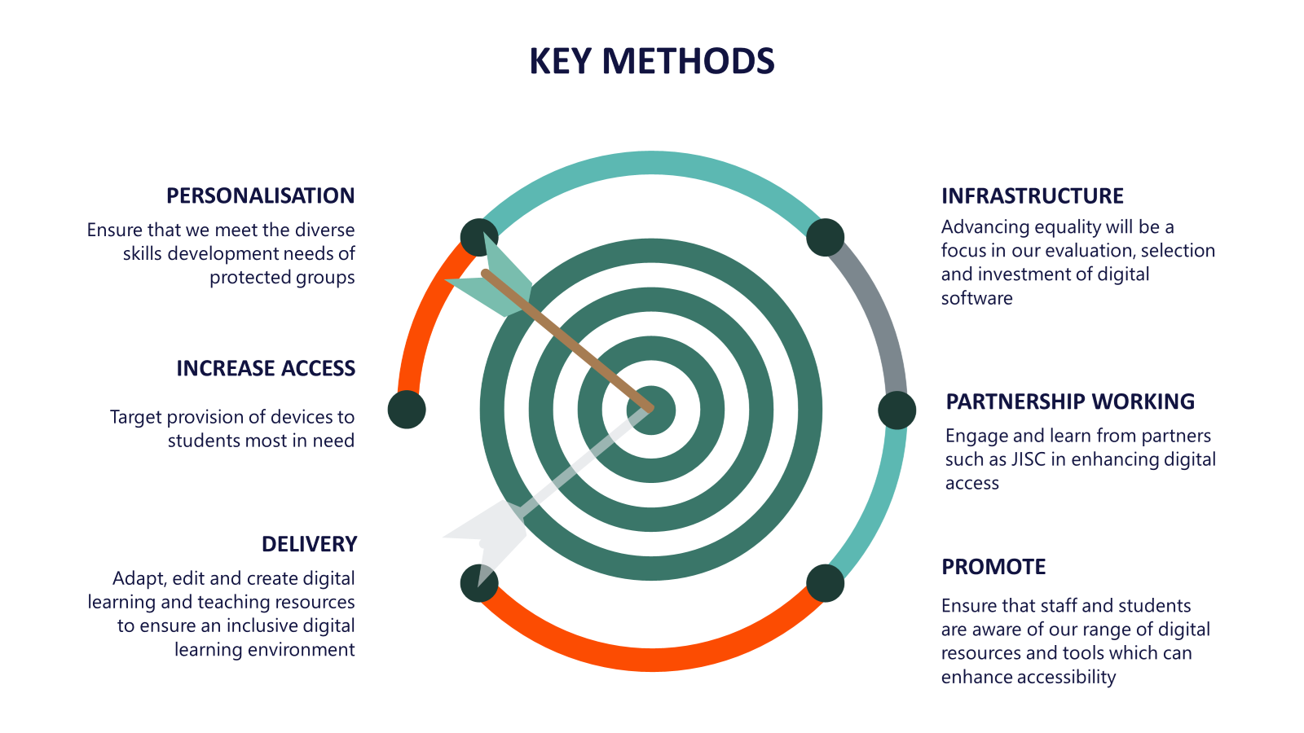

During and post pandemic, staff and students from protected groups are supported and engaged in the recovery process.

Action | Responsibility | Date | Indicators
Conduct Staff Survey to learn about pandemic experience | Dir OD&HR | May 21 | Survey results
Use output of Staff Survey to inform EDI practice | EDI Manager | June 21 | Enhancement of practice
Conduct Student Survey | AP Performance and Skills | November 21 | Survey results
Use output of Student Survey to inform EDI practice | EDI Manager | December 21 | Enhancement of practice
Engage with Student Association re recovery/transition | EDI Manager | June 21 | Output of engagement
Mainstream equality in transition | EDI Manager | AY 2020-2021 | Transition supports protected groups
Ensure health and safety practice considers diverse requirements of protected groups | Head OD&HR | May 21 | Health and Safety processes are inclusive
Review pandemic Communications; assess and use to inform future Communications | EDI Manager | June 21 | Communications assessment
Analyse emerging data regarding protected characteristics of 2021-2022 and use to inform practice and focus resource. | EDI Manager | June 21 | Data sharing with EDI Committee

We stand up to racism and progress race equality.

Action | Responsibility | Date | Indicators
Review recruitment using the Scottish Government Race Equality Toolkit. Use results of review to develop practice to attract diversity. | Dir OD &HR | Jan 22 | Outputs of Review shared with EDI Committee
Analyse occupational segregation with reference to BAME staff | EDI Manager | Sep 21 | Analysis shared
Enhance staff understanding of racism with CPD | Head OD&HR | Dec 22 | Increased competency
Critically assess institutional barriers | EDI Manager | Mar 22 | Identification of barriers
Raise awareness of unconscious bias through promotion of Project Implicit | OD Manager | Jan 22 | Increased awareness
Promote recruitment opportunities on diverse media | EDI Manager | Dec 22 | Evidence of reach
Publicly communicate leadership commitment to being an ally | Communications and Marketing | Sep 21 | Statement promoted
Aim to Increase proportion of BAME staff from 1.7% to 2.5% | Dir OD &HR | April 23 | Recruitment data

We enhance the wellbeing of our staff and students

Action | Responsibility | Date | Indicators
Investigate further student data to understand more about concentration of students with mental health conditions in curriculum areas. Share findings with Curriculum Quality Leaders and Enabling Services. | EDI Manager | Mar 22 | Data sharing
Further develop College communication mechanisms to promote awareness of wellbeing and signpost supports and resources available. | Healthy Working Lives | Jan 22 | Increased engagement with online College resources available
Promote existing resources to support staff wellbeing. | Healthy Working Lives | Aug 21 | Increased number of staff engaging with various support mechanisms
Implement student and staff initiatives which promote wellbeing. | Healthy Working Lives | June 22 | Decreased stigma and increased initiatives
Plan, deliver and evaluate at least three College-wide promotional campaigns throughout the academic session. | Healthy Working Lives | June 22 | Increased staff and student awareness of strategies to support wellbeing
Identify and share examples of best practice related to wellbeing across learning and teaching within the College. | EDI Manager | Sep 22 | Enhanced practice
Develop a training matrix to provide staff with access to CPD in relation to wellbeing. | Head of OD & HR | Jan 23 | Staff training matrix in relation to wellbeing developed
Improve how we respond to survivors of gender based violence | AP Student Life and Skills | Jan 23 | Increase in staff competencies
Develop further partner networks to enhance practice | EDI Manager | June 22 | Increase in College partnerships
Digital Wellbeing Workstream to develop initiatives to enhance wellbeing | AP Creativity and Skills | Dec 21 | Improvement in wellbeing

We are digitally inclusive

Action | Responsibility | Date | Indicators
Share best practice in digital inclusion with Digital Strategy Group | EDI Manager | June 21 | Increased confidence in digital inclusion
Learn from emerging evidence regarding digital learning and use to inform action to improve digital inclusion | EDI Manager and AP Creativity and Skills | Dec 21 | Evidence inform inclusive practice
Review Equality Audit Tool to incorporate increased focus on digital access | AP Performance and Skills | Jan 23 | Audit Tool more responsive to digital inclusion
Ensure digital inclusion is embedded within our evaluation, selection and investment in digital software | Director of Infrastructure | April 23 | Software meets the needs of protected groups
Engage further with JISC to enhance practice | Enabling Services Manager  AP Creativity and Skills | Jan 23 | Enhanced practice
Target provision of devices to students most in need | Director of Infrastructure and AP Creativity and Skills | Annually until June 2023 | Number of devices
Promote awareness of College’s range of digital resources and tools which complement accessibility | Communications and Marketing: Digital Strategy Group | Annually until June 2023 | Increased awareness of resources and support available

