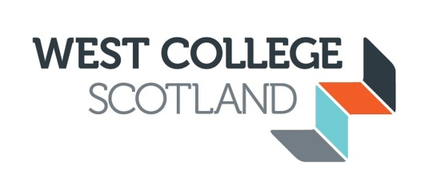

GOVERNANCE

The Board of Management of West College Scotland was established under the provisions of the Further and Higher Education (Scotland) Act 1992. The Board is responsible for the governance of the College and has a duty to strategically manage the College in order to ensure that it provides suitable and efficient education to its students.

The Board has 18 members, comprising:
- The Chair of the Board as appointed by the Scottish Ministers
- The Principal
- Two staff members: one elected by the Teaching staff of the College and one elected by the Support staff of the College
- Two student members nominated by the Students Association
- 12 Non-Executive (External) Board members.

The Non-Executive Board members serve on a voluntary basis and are not remunerated. They are normally appointed for a period of up to 4 years, and may serve for a second term of office, also up to a maximum of 4 years. The Board normally meets 5 times per year and is supported by a number of committees. Board minutes are published on this website once they have been approved.

Board members are required to comply with the Code of Good Governance for Scotland’s Colleges and, under the terms of the Ethical Standards in Public Life etc (Scotland) Act 2000, are required to comply with a Code of Conduct which includes the maintenance of a Register of Interests. The Register of Interests for Board members is also available on this website.

